**Design Document**

**Team:** CSM #2

**Project:** Machine Shop Electronic Access/Inventory System

**Client:** Dr. Kevin Moore

**Current Design Issues**

* Accessing a Mines database that contains information about students (which can be extracted given their CWID) has been a roadblock so far. The only information we are concerned about is name, e-mail address, and whether the person is a current student at Mines.
* As of yet we do not have a dedicated space on a server on the Mines network to host our MongoDB instance that will be storing all of the persisted data for our project.
* All of the other issues we have run into, such as how to query the MongoDB instance and translate JSON into Java, have been solved by researching online.

**Software**

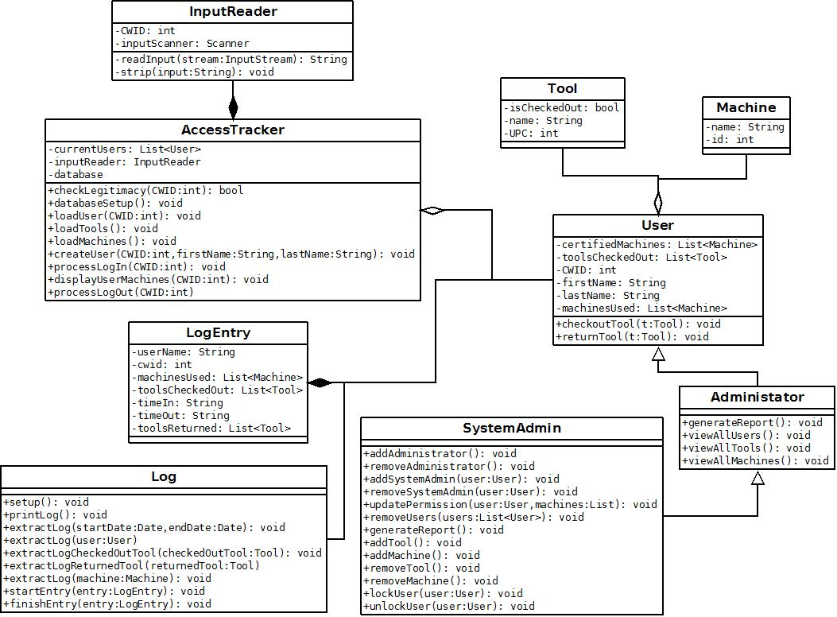

**Database**

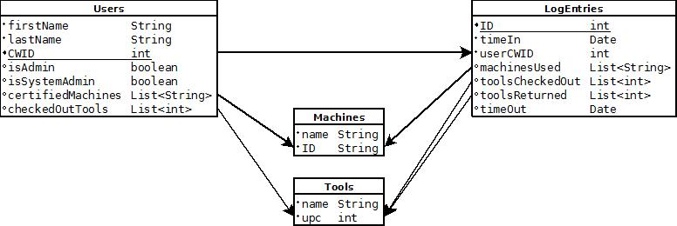

**Overall System**

